Landing Pages 頁面初步需求（Jara Holidays）06.13
LangkawiByLocals.com （網址）
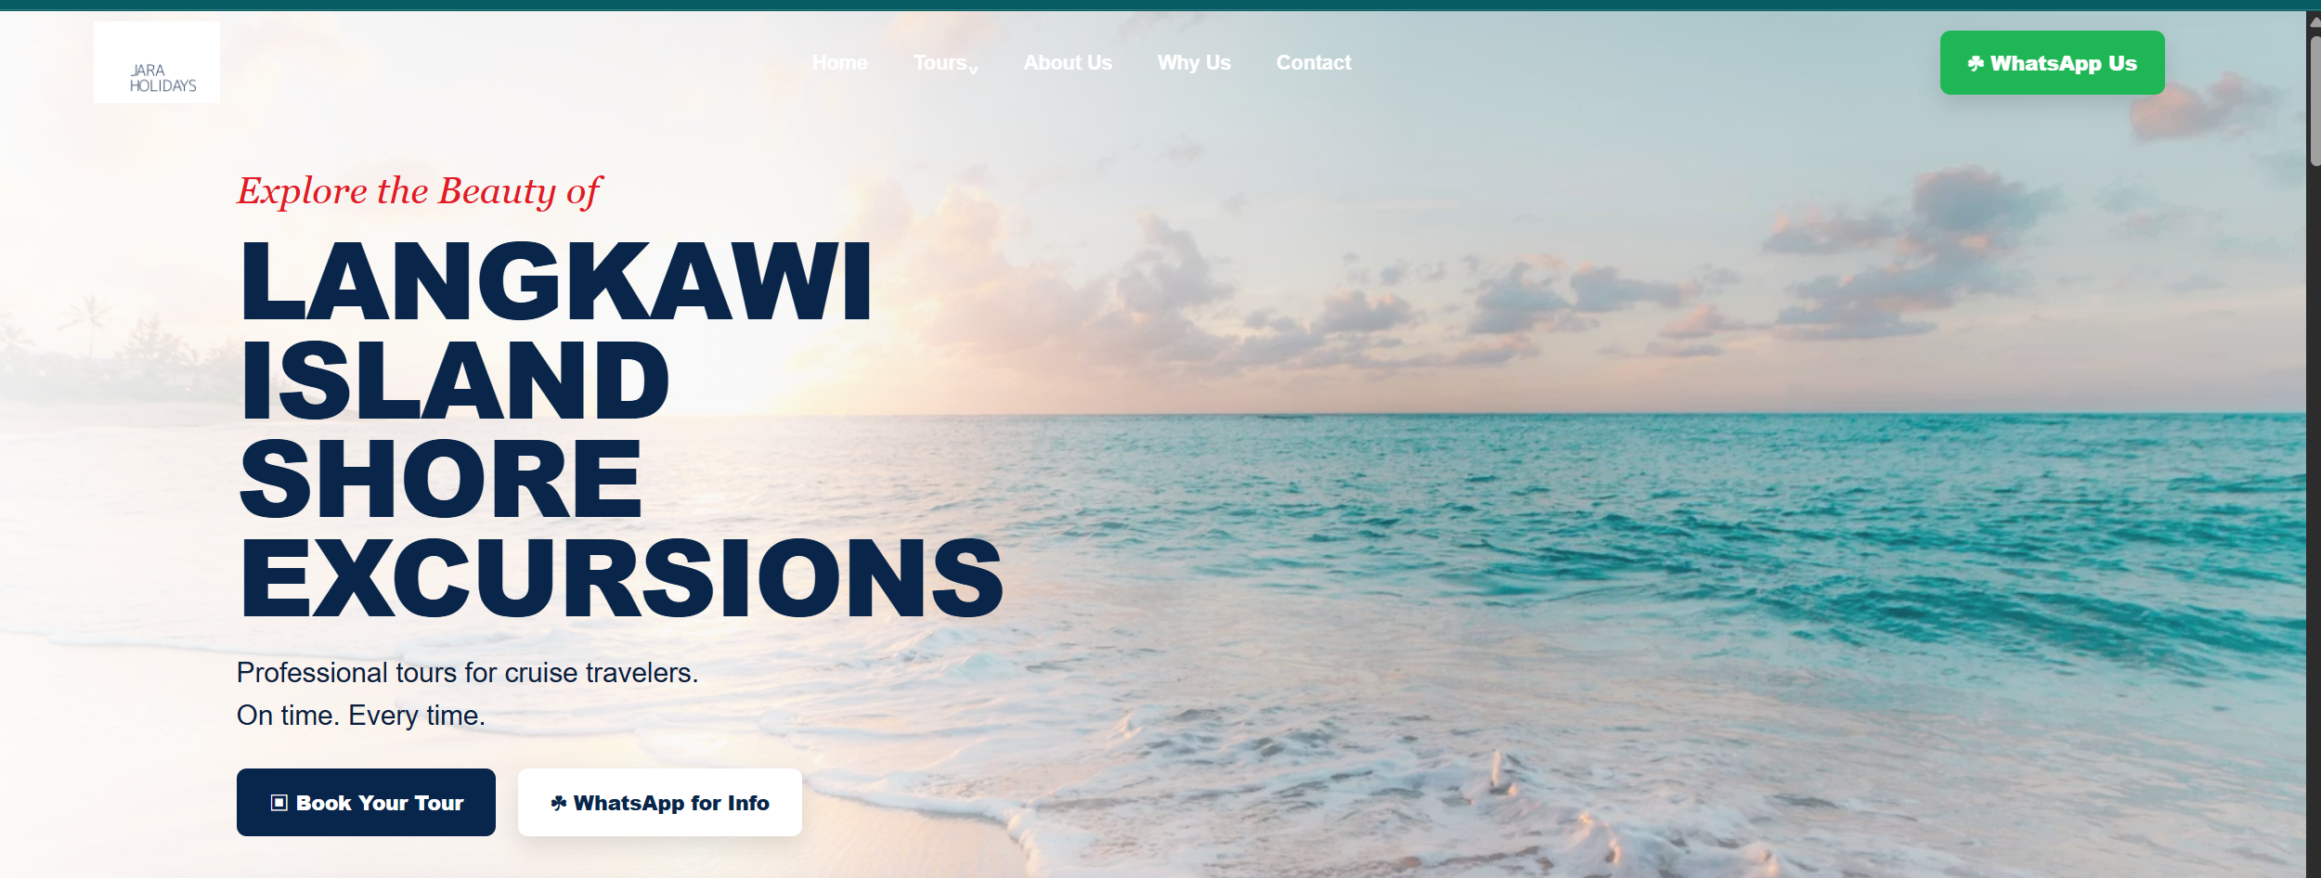
客户网站结构：
1. Header / Navigation Bar
- Logo
- Highlights
- Tours
- Private Driver
- Why Us
- About
- Contact
- WhatsApp Button
- Book Your Tour
↓ 点击菜单后往下跳转
2. Hero Banner
- Langkawi Shore Excursions
- Private Tours • Shared Tours • German-Speaking Tours
- Book / WhatsApp CTA
↓
3. Key Selling Points
- Cruise Friendly
- Guaranteed Return To Ship
- Comfortable Transport
- Local Experts
↓
4. Tour Highlights / 景点展示
- Eagle Square
- Durian Perangin Waterfalls
- Tanjung Rhu Beach
- Kilim Mangrove Boat Tour
- Langkawi Cable Car
- Langkawi Sky Bridge
↓
5. Tour Packages / 配套选择
这里是卡片式展示，点击后往下跳转
A. Shared Tour
- From USD45
B. Shared Tour with Tickets
- USD120
- Most Popular
C. Private Tour
- USD160
D. German-Speaking Tour
- EUR120
E. Private Driver & Transport Services
- EUR？

↓
6. Shared Tour Section
- USD45 Basic Shared Tour
- USD120 Shared Tour with Tickets
- 包含 / 不包含内容
- WhatsApp Booking Button

↓
7. Private Tour Section
- USD160 Per Person
- Private Vehicle
- Private Driver
- Flexible Schedule
- No Sharing
- Tickets Included
- WhatsApp Booking Button
↓
8. German-Speaking Tour Section
- EUR120 Per Person
- German-speaking guide
- German itinerary
- Includes Cable Car, Sky Bridge, Mangrove Tour
- Guaranteed return to cruise ship
- WhatsApp Booking Button

↓

9. Private Driver & Transport Services
- Sedan
- MPV
- Van
- Airport Transfer
- Cruise Port Transfer
- Half Day Charter
- Full Day Charter
- MPV Rental with Driver
- Car Rental Arrangement
↓
10. Why Book With Us
- Local Langkawi Specialist
- Cruise Passenger Focused
- Guaranteed Return
- Bottled Water Included
- Top Photo Stops
- Friendly Local Team
↓
11. About Us
- Jara Holidays introduction
- Local Langkawi shore excursion specialist
- Experienced drivers / guides
- Easy WhatsApp support

↓

12. Contact / Final CTA
- WhatsApp: +60 12-365 9345
- Book Now
- Ask for More Info
↓
13. Footer
- Tour Packages
- Services
- Contact

以下為客戶提供資訊：
LANGKAWI SHORE EXCURSIONS
### Private Tours • Shared Tours • German-Speaking Tours
Explore Langkawi's most famous attractions with convenient cruise port pickup, experienced local hosts, and guaranteed return to your ship.
Tour Highlights
📍 Eagle Square (Dataran Lang)
📍 Durian Perangin Waterfalls
📍 Tanjung Rhu Beach
📍 Kilim Mangrove Boat Tour
📍 Langkawi Cable Car
📍 Langkawi Sky Bridge
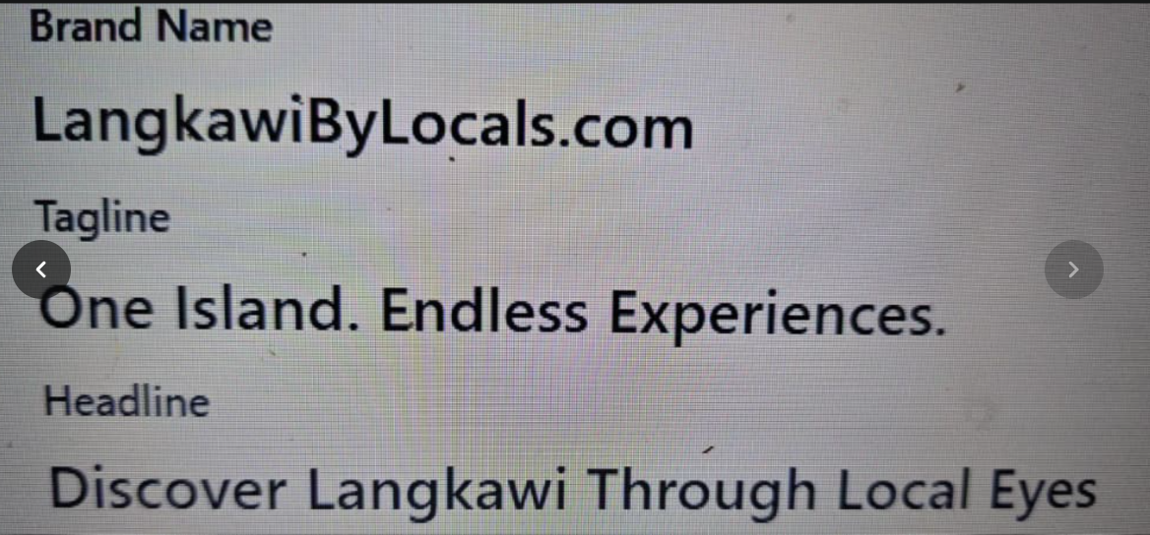
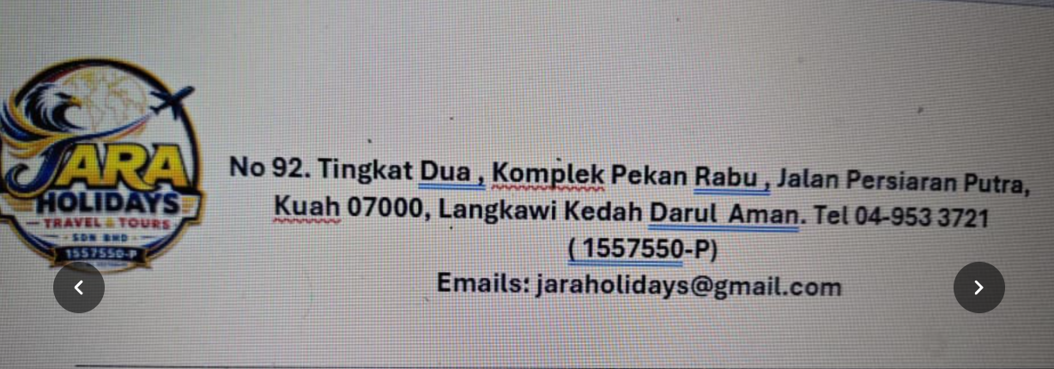
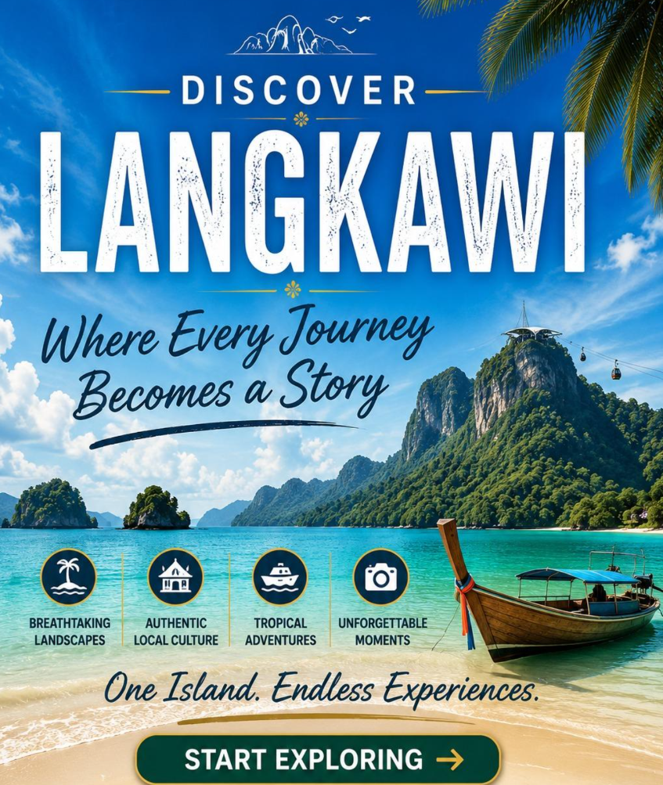
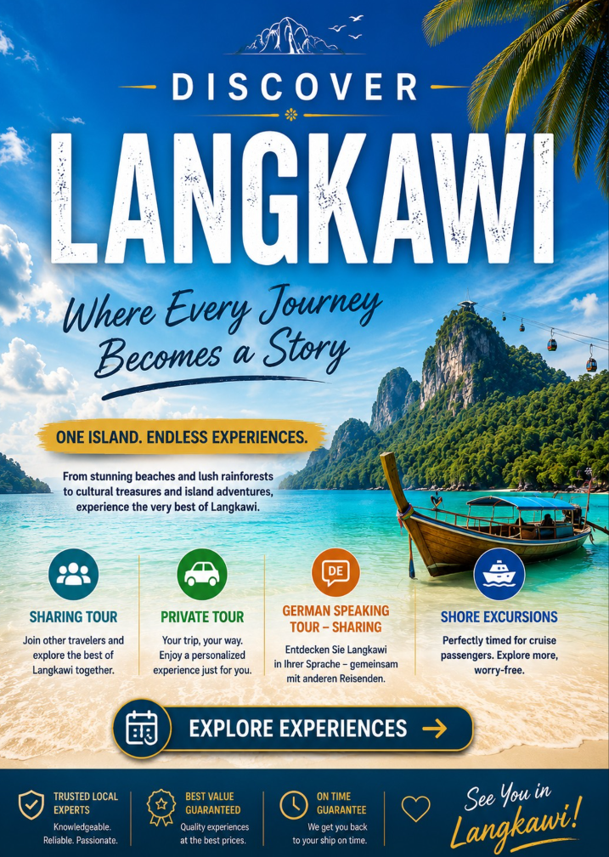
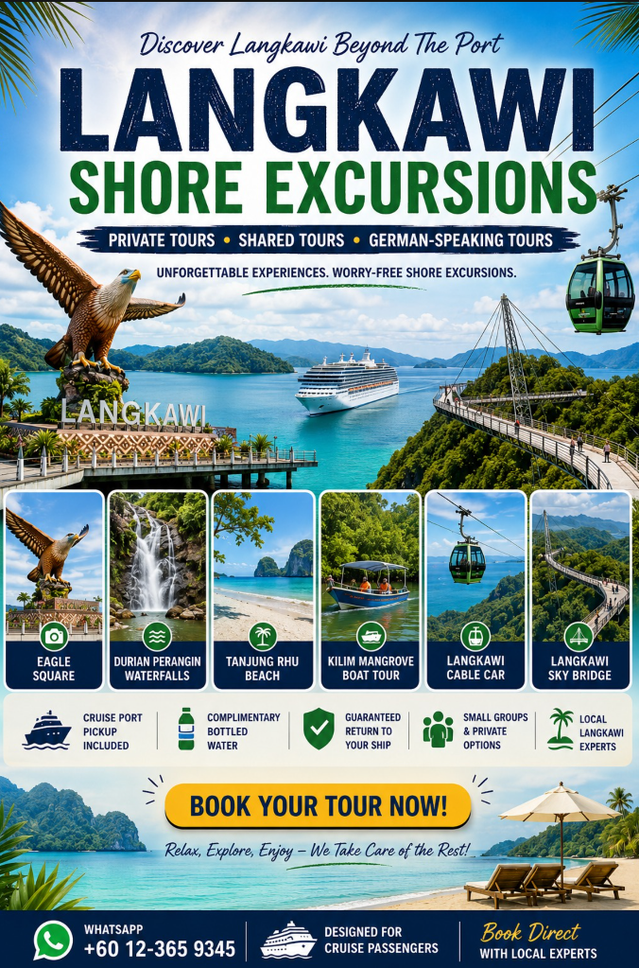
*但有關郵輪、地標、纜車等元素都可以不用出現，出現海岸即可
按鈕 | 對應内容
Home | 跳到最上方
Tours | 跳到對應介紹  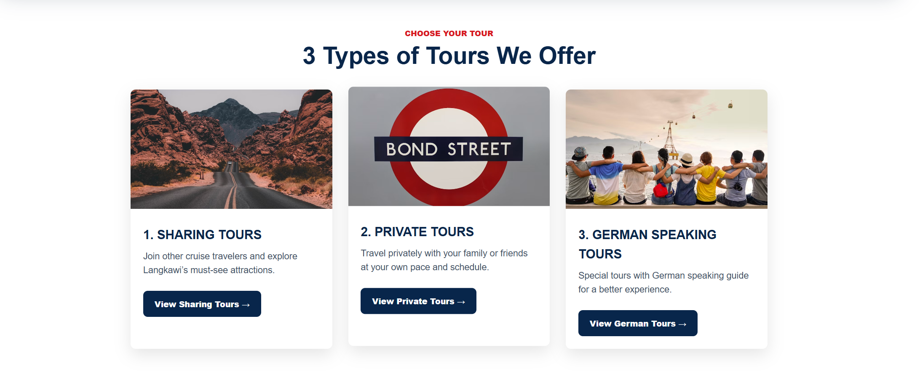
About Us | 跳到對應介紹  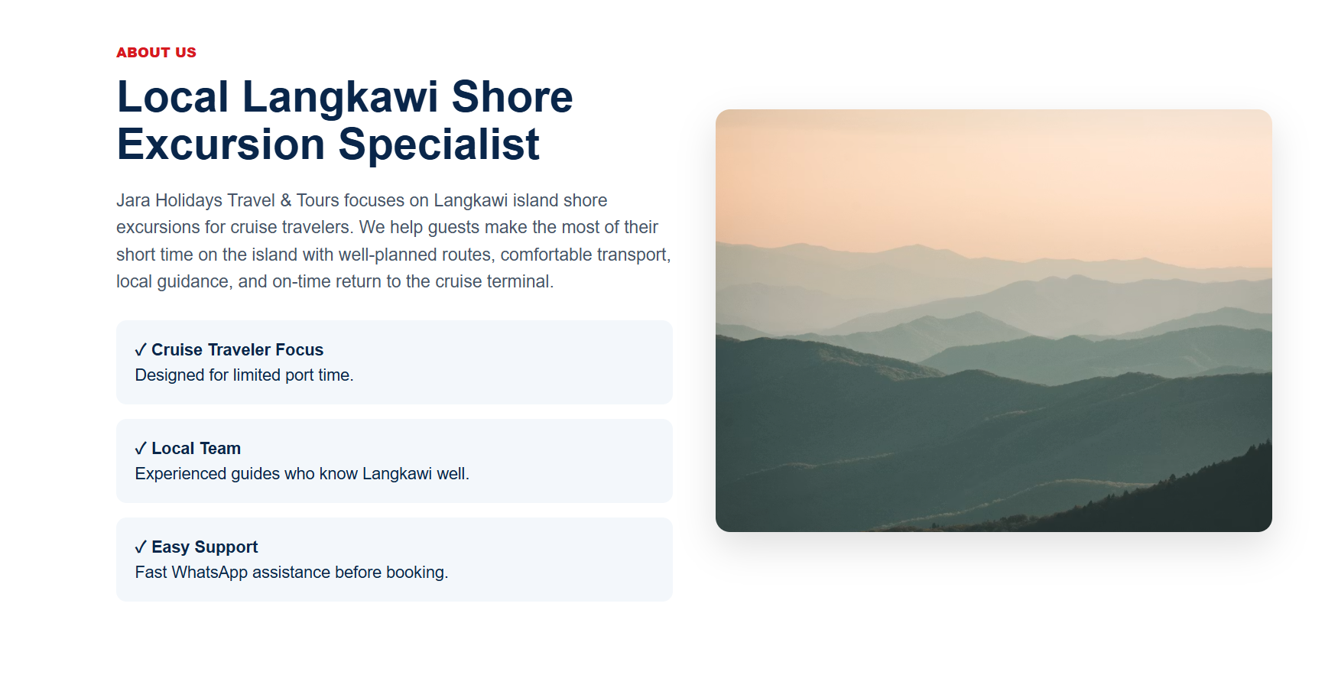
Why Us | 跳到對應介紹  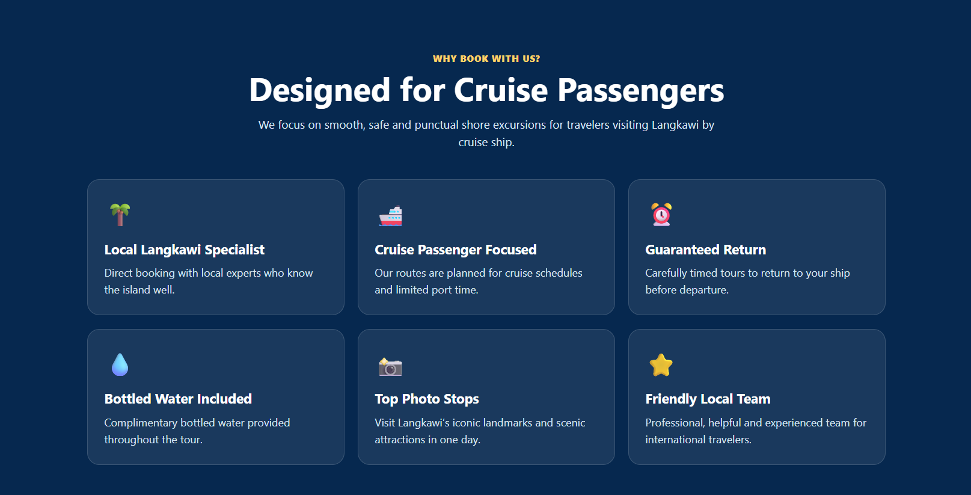  以下爲客戶提供的資訊：  Why Book With Us?  ✅ Local Langkawi Shore Excursion Specialist  ✅ Cruise Passenger Focused  ✅ Guaranteed Return to Your Ship  ✅ Small Groups & Private Options  ✅ Direct Booking with Local Experts  Additional Inclusions for All Tours  ✔️ Complimentary Bottled Water  ✔️ Cruise Port Pickup & Drop-off  ✔️ Air-Conditioned Vehicle  ✔️ Local Driver or Guide  ✔️ Guaranteed Return to Your Cruise Ship  Why Travelers Love Our Tours  💧 Complimentary bottled water provided throughout the tour  🚢 Designed specifically for cruise passengers  🌴 Visit Langkawi's top attractions in one day  📸 Plenty of photo stops at iconic landmarks  ⏰ Carefully timed to match your ship's schedule  ⭐ Friendly local team with extensive knowledge of Langkawi
Contact | 跳到對應介紹  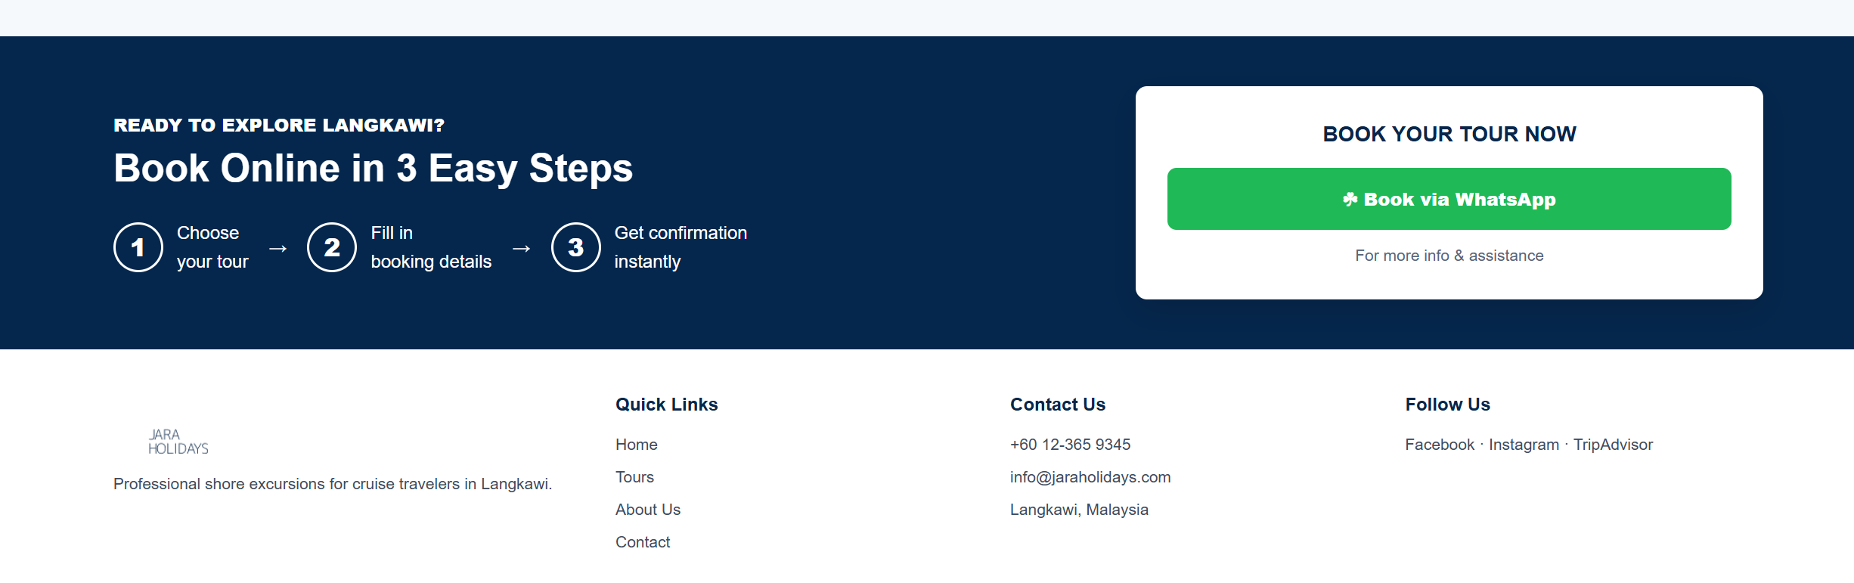
Book Your Tours | 跳轉到訂購資訊填寫  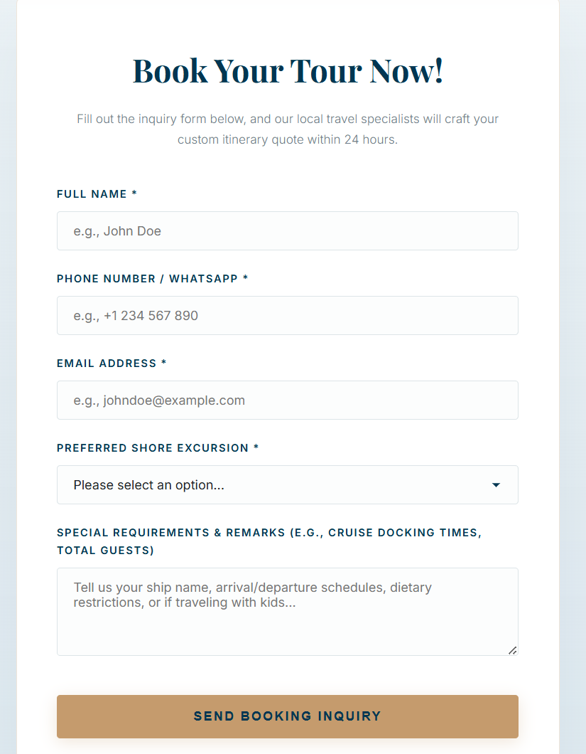
WhatsApp Us | 跳轉到與Jara公司WhatsApp聊天溝通
Sharing Tours | Sharing Tours with ticket  以下爲客戶提供的資訊：  🌴 Shared Tour with Tickets Included  ### USD 120 Per Person  Our most popular shore excursion package.  ✔️ Cruise Port Pickup & Drop-off  ✔️ Shared Air-Conditioned Transportation  ✔️ Eagle Square  ✔️ Durian Perangin Waterfalls  ✔️ Tanjung Rhu Beach  ✔️ Langkawi Cable Car Ticket Included  ✔️ Langkawi Sky Bridge Ticket Included  ✔️ Kilim Mangrove Boat Tour Ticket Included  ✔️ English-Speaking Tour Coordinator  Sharing Tours without ticket  以下爲客戶提供的資訊：  🚐 Shared Tour  ### USD 45 Per Person  Perfect for budget-conscious travelers.  ✔️ Cruise Port Pickup & Drop-off  ✔️ Shared Air-Conditioned Transportation  ✔️ Friendly Local Driver  ✔️ Eagle Square  ✔️ Durian Perangin Waterfalls  ✔️ Tanjung Rhu Beach  * oriental village  ❌ No Tour Guide  ❌ No Entrance Tickets Included  ❌ No Mangrove Boat Tour Included  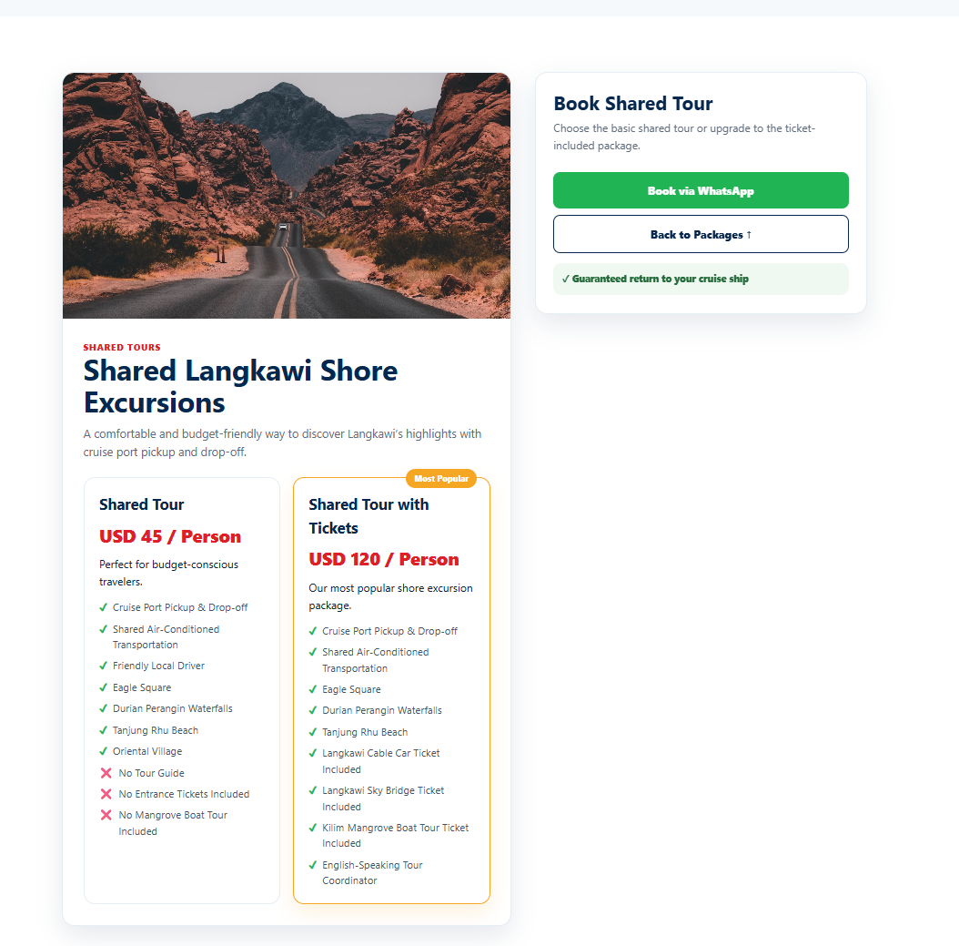
Private Tours | 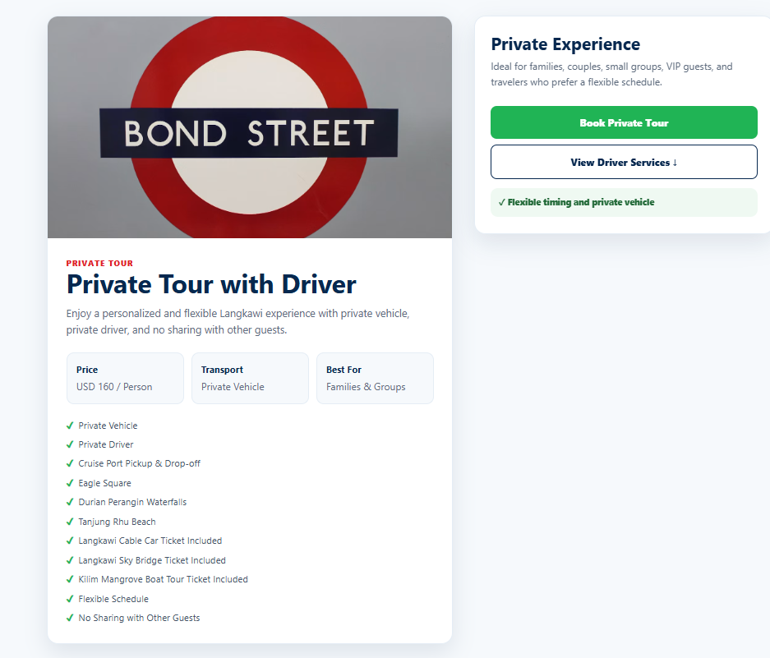  以下爲客戶提供的資訊：  Private Tour  ### USD 160 Per Person  Enjoy a personalized and flexible experience.  ✔️ Private Vehicle  ✔️ Private Driver  ✔️ Cruise Port Pickup & Drop-off  ✔️ Eagle Square  ✔️ Durian Perangin Waterfalls  ✔️ Tanjung Rhu Beach  ✔️ Langkawi Cable Car Ticket Included  ✔️ Langkawi Sky Bridge Ticket Included  ✔️ Kilim Mangrove Boat Tour Ticket Included  ✔️ Flexible Schedule  ✔️ No Sharing with Other Guests
German Speaking Tours | 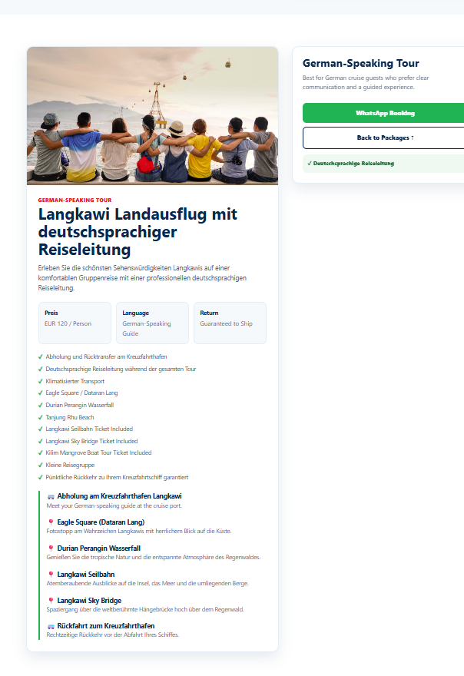  以下爲客戶提供的資訊：  🇩🇪 German-Speaking Tour  ### EUR 120 Per Person  Explore Langkawi with a live German-speaking guide.  ✔️ Cruise Port Pickup & Drop-off  ✔️ Shared Air-Conditioned Transportation  ✔️ Professional German-Speaking Tour Guide  ✔️ Eagle Square  ✔️ Durian Perangin Waterfalls  ✔️ Tanjung Rhu Beach  ✔️ Langkawi Cable Car Ticket Included  ✔️ Langkawi Sky Bridge Ticket Included  ✔️ Kilim Mangrove Boat Tour Ticket Included  ✔️ Guided Tour Throughout the Excursion  ✔️ Guaranteed Return to Your Cruise Ship  德語：  🇩🇪 Langkawi Landausflug mit deutschsprachiger Reiseleitung  Preis: €120 pro Person  Erleben Sie die schönsten Sehenswürdigkeiten Langkawis auf einer komfortablen Gruppenreise mit einer professionellen deutschsprachigen Reiseleitung.  ✔️ Abholung und Rücktransfer am Kreuzfahrthafen  ✔️ Deutschsprachige Reiseleitung während der gesamten Tour  ✔️ Klimatisierter Transport  ✔️ Besuch des Eagle Square (Dataran Lang)  ✔️ Besuch des Durian Perangin Wasserfalls  ✔️ Fahrt mit der berühmten Langkawi Seilbahn  ✔️ Eintritt zur spektakulären Langkawi Sky Bridge  ✔️ Kleine Reisegruppe  ✔️ Pünktliche Rückkehr zu Ihrem Kreuzfahrtschiff garantiert  Reiseverlauf:  🚐 Abholung am Kreuzfahrthafen Langkawi  📍 Eagle Square (Dataran Lang)  Fotostopp am Wahrzeichen Langkawis mit herrlichem Blick auf die Küste.  📍 Durian Perangin Wasserfall  Genießen Sie die tropische Natur und die entspannte Atmosphäre des Regenwaldes.  📍 Langkawi Seilbahn  Atemberaubende Ausblicke auf die Insel, das Meer und die umliegenden Berge.  📍 Langkawi Sky Bridge  Spaziergang über die weltberühmte Hängebrücke hoch über dem Regenwald.  🚐 Rückfahrt zum Kreuzfahrthafen  Rechtzeitige Rückkehr vor der Abfahrt Ihres Schiffes.  Warum diese Tour wählen?  ✓ Professionelle deutschsprachige Reiseleitung  ✓ Speziell für Kreuzfahrtgäste entwickelt  ✓ Die wichtigsten Sehenswürdigkeiten an einem Tag  ✓ Komfortabler Transport und kleine Gruppen  ✓ Lokaler Veranstalter mit langjähriger Erfahrung
Private Driver | 這是客戶要介紹交通的、例如汽車、租借、MPV之類的  